**Project Plan**

Date: Mar 27, 2017

Team: Dr. Stranger

Members: Jiacheng CHEN, Jiahuan HE, Jiayu WANG, Yiming JIANG

1. **Project Goal**

The goal of the project is to build a working system for file sharing. We suppose to have multiple servers (possibly start with two servers) running to provide services to interact with multiple clients. The client side may take the responsibility of connection establishment, forwarding the command to server, and handling the circumstances where the connection cannot be established. The server, on the other hand, will handle all the coming messages from the client and provide functions like publishing files, sharing files, removing files, querying files, downloading files, and exchanging information with other known servers.

1. **Tools and Communication**

We have decided to use Git to perform version control and created repository on Github. Besides, we will use our WeChat group as preferred communication tool, and we will hold a weekly meeting on every Monday afternoon.

1. **Timeline**

The whole period for development would be 4 weeks. We have all agreed on the first week to work out a couple of elements that has lower dependencies, and then implement all required functions on a working product by end of the second week. For week three, we plan to perform detailed testing on all aspects of the system and finally, writing reports in week four.

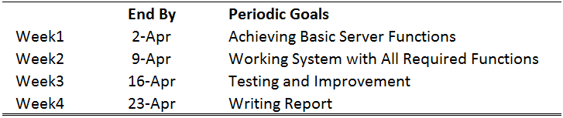

1. **Decomposed Tasks and Allocation**

Please see below:

